Kurdistan Region – Iraq  Lebanese French University  College of Administration & Economics  Business Administration Department |  | هەرێمی كوردستان-عێراق  زانكۆی لوبنانی فەرەنسی  كۆلێژی کارگێری و ئابوری  بەشی كارگێری كار

GRADUATION PROJECT GUIDELINES FOR UNDERGRADUATE STUDENTS
2021-2022

Prepared by:
Nabaz Nawzad Abdullah

The guideline has been prepared in order to assist undergraduate students to prepare and complete their graduation project. The guideline benefits students to avoid burdens and misunderstanding of the general requirement of their projects.

This guideline includes both general format of how to structure the project and also technical formats such as font size, length of the project, margins and spacing. If students or supervisors have any question regarding the contents of this guide, they should directed to the head of graduation project committee at the Department of Business Administration, Collage of Administration & Economics, Lebanese French University.

TABLE OF CONTENTS

TABLE OF CONTENTS 2
1.0 General Form and Style 4
1.1 Length of Project 4
1.2 Typing or Computer Printing 4
1.3 Margins 4
1.4 List of Tables 5
1.5 List of Figures 5
1.6 Arrangement of Contents 6
1.7 Abstract 6
1.8 Referencing 6
SAMPLE COVER 8
TABLE OF CONTENTS 10
LIST OF TABLES 11
LIST OF FIGURES 12
LIST OF APPENDICES 13
LIST OF ABBREVIATIONS 14

1.0 General Form and Style
Students are given a chance to write their graduation project in their language of preference including Kurdish, Arabic and English. Therefore, the consistency of styles through the project must be considered and the rules of grammar must be followed. The students and assigned supervisors must ensure that the language of the project is clear and comprehensive.

The main body of a project should contain the following:
- Introduction;
- Problem Statement;
- Research Questions;
- Research Objectives;
- Significance of the Research.
- Literature Review;
- Methodology;
- Results & Discussions
- Results and Conclusion;
- References.

1.1 Length of Project
The recommended length of the main body of graduation project is 40 – 80 pages excluding appendixes.

1.2 Typing or Computer Printing
The entire body text of the project, including heading and page numbers, must be same font or typeface.
- Font Style: Times New Roman
- Font Size: 12 point (body text)
- Spacing: Double Space (except for abstracts)

Note: The direction of the text changes in Kurdish and Arabic.

1.3 Margins
Margin specifications are meant to facilitate binding and trimming. The stipulated margins for the general text are as follows:
- Top edge : 2.5 cm (1 inch)
- Right side : 2.5 cm (1 inch)
- Left side : 4.0 cm (1.5 inches)
- Bottom edge : 2.5 cm (1 inch)

1.4 List of Tables
Each table caption must be placed at the left and on top of the table (title case). Table Heading should be as shown below:

Table 1.1
Reliability Analysis of Pilot Study
Construct | N. of Items | Cronbach’s Alpha
Deliberation | 10 | 0.836
Communication | 9 | 0.808
Information | 8 | 0.884
Capital budgeting Process | 16 | 0.889

1.5 List of Figures
Place the word Figure and the figure number under the figure, flush left in italics. The title of the figure goes next to the number in sentence case as following:

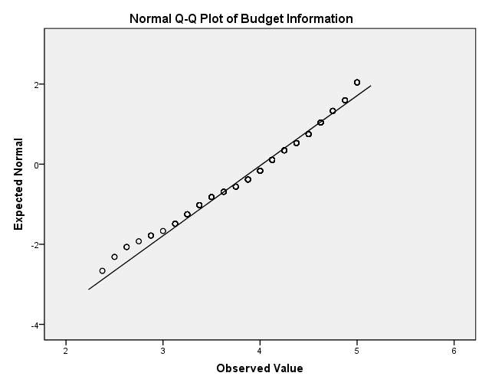

Figure 1.1 Normal Q-Q Plot of Budget Information

1.6 Arrangement of Contents
Following is the order of all the elements of the project:
Title Page
پوخته‌ (in Kurdish)
Abstract (in English)
ملخص (in Arabic) --- If the language of the project is Arabic
Acknowledgement
Table of contents
List of Tables
List of Figures
List of Abbreviations (if it’s applicable)
References
Appendices (if any)

1.7 Abstract
An abstract must be in Kurdish, English and Arabic if the candidate decides to write the project in Arabic. The abstract should identify clearly the purpose of the research, the methods used, the results obtained and the significance of the results or findings. The abstract must not exceed 350 words.

1.8 Referencing
The students are required to use complete, reliable and correct sources for their projects. The same format must be used for references throughout the project. Students are required to use the APA style in their choice of format for citation and references.

Book with one authors
Wildavsky, A. B. (1986). Budgeting: a comparative theory of the budgeting process. New York: Transaction Publishers.

Book with two authors
Bryman, A., & Bell, E. (2015). Business research methods. Oxford University Press, USA.

Book with more than two authors
Krause, K.-L., Bochner, S., & Duchesne, S. (2006). Educational psychology for learning and teaching (2nd ed.). Melbourne, Australia: Thomson.

Journal article
Harris, M., & Raviv, A. (1996). The capital budgeting process: Incentives and information. The Journal of Finance, 51(4), 1139-1174.

Newspaper article (electronic version)
Brody, J. E. (2007, December 11). Mental reserves keep brain agile. The New York Times. Retrieved from http://www.nytimes.com

Newspaper article (print version)
Schwartz, J. (1993, September 30). Obesity affects economic, social status. The Washington Post, pp. A1, A4.

Conference Proceedings
Armstrong, D. B., Fogarty, G. J., & Dingsdag, D. (2007). Scales measuring characteristics of small business information systems. In W-G. Tan (Ed.), Proceedings of Research, Relevance and Rigour: Coming of age: 18th Australasian Conference on Information Systems (pp. 163-171). Toowoomba, Australia: University of Southern Queensland.

SAMPLE COVER

THE EFFECTS OF PARTICIPATORY BUDGETING ON PUBLIC SERVICE SATISFACTION: A CASE STUDY OF KURDISTAN

NABAZ NAWZAD ABDULLAH

BACHELOR OF BUSINESS ADMINISTRATION
LEBANESE FRENCH UNIVERSITY
MAY 2018

THE EFFECTS OF PARTICIPATORY BUDGETING ON PUBLIC SERVICE SATISFACTION: A CASE STUDY OF KURDISTAN

NABAZ NAWZAD ABDULLAH

A project submitted to Business Administration Department
In fulfilment of the requirements for the degree in business administration at Lebanese French University

TABLE OF CONTENTS

ABSTRAK (ENGLISH) 10
ABSTRACT (KURDISH) 11
ABSTRACT (ARABIC) 12
ACKNOWLEDGEMENT 13
TABLE OF CONTENTS 14
LIST OF TABLES 15
LIST OF FIGURES 16
LIST OF APPENDICES 25
LIST OF ABBREVIATIONS 54

CHAPTER I INTRODUCTION 11
1.0 Introduction 11
1.1 Statement of the Problem 12
1.2 Research Questions 14
1.3 Objectives of the Research 15
1.4 Significant of the Study 16
1.5 Scope of the Study 17
1.6 Chapter Summary 18

CHAPTER II : LITRATURE REVIEW 19

LIST OF TABLES
Table 2.1 Kurdistan Budget (2004-2014) ……………………………….………..15
Table 2.2 CSDP II Details ………………………………………………….……..30
Table 3.1 Citizens Top Priorities in Porto Alegre PB 1992-2005 ………………..49
Table 4.1 Reliability Analysis of Pilot Study ……………………………….…...110
Table 4.2 Sample Size …………………….……………………………………..112

LIST OF FIGURES
Figure 2.1 Budgeting process in Kurdistan ……………………….……….……..27
Figure 2.2 CSDP cycles …………………………………..…………………..…..34
Figure 3.1 Budgetary participation through communication………………….......72
Figure 4.1 Participatory budgeting processes in Peru ………………………....….86

LIST OF APPENDICES
Appendix A Questionnaire (English) ...……………………………...…….…......…..227
Appendix B Questionnaire (Kurdish) …...…………………………………...…….…242
Appendix C Pilot Test ………………………………………………………....……...247

LIST OF ABBREVIATIONS
ACDI Agricultural Cooperative Development International
BOI Board of Investment
CAG Community Action Group

